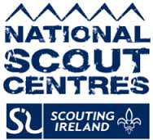

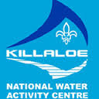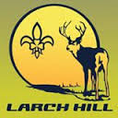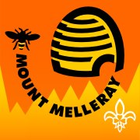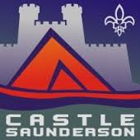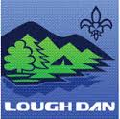

**Smoking Policy**

Scouting Ireland National Scout Centres are committed as part of their overall philosophy to “Discourage the use of Smoking on the basis that it is incompatible with a healthy approach to Scouting activity.”

All staff and visitors should display leadership and good example, particularly when around youth members.

Please consult a member of staff to locate the smoking area in the campsite.

There is legislation in place, which prohibits smoking within buildings as per the provisions of the Public Health (Tobacco) Act 2002. This policy applies to all members, visitors, and contractors.

Information and support around quitting smoking is available from the National Smoker’s Quit line on 1850 201203 or from the local Health Promotion departments of the HSE (ROI) or

Smokers Helpline on 0800 858585 in Northern Ireland